Deployment of a Parametric Model for Weekly Sales Prediction
Context
The objective is to deploy a parametric model for predicting weekly sales under the following constraints:
- The model will be reviewed by non-technical stakeholders
- Predictions will be used for budget allocation decisions
- Model updates are allowed only once per quarter
These constraints require the model to prioritize interpretability, stability, and governance, rather than maximizing predictive accuracy alone.
1. Selection of Parametric Model Algorithm
Chosen Model: Multiple Linear Regression
Justification: Multiple Linear Regression is the most appropriate parametric model for this setting for the following reasons:
- High interpretability: Each coefficient represents the marginal impact of a predictor on weekly sales, making the model easy to explain to non-technical stakeholders.
- Transparency: The linear functional form makes all relationships explicit, supporting trust, auditability, and accountability.
- Stability over time: Linear regression has low variance and is less sensitive to small data fluctuations, which is critical when models are updated only quarterly.
- Suitability for budget allocation: Linear coefficients enable clear and reliable “what-if” analysis (e.g., impact of increasing advertising spend), which is essential for budget planning and decision-making.
Why other parametric models are not preferred
- Polynomial regression introduces non-linear terms that complicate interpretation and can lead to unstable extrapolation.
- Lasso or Elastic Net may eliminate variables entirely, which can confuse stakeholders and create governance challenges.
- Time-series parametric models (e.g., ARIMA) are harder to explain and less aligned with feature-driven budget allocation decisions.
2. Deliberate Modeling Simplifications
To align with business and governance requirements, certain modeling choices are intentionally restricted.
2.1 Restriction on Feature Transformations
- No polynomial terms or complex interaction effects are included.
- All predictors enter the model in their original or minimally transformed form.
Rationale:
While non-linear transformations may slightly improve predictive accuracy, they significantly reduce interpretability. For budget allocation decisions, understanding the direction and magnitude of each driver’s impact is more valuable than marginal accuracy gains.

2.2 Conservative Use of Regularization
- Either no regularization or very mild Ridge regularization is applied.
- Aggressive regularization techniques such as Lasso are avoided.
Rationale:
Strong regularization can cause coefficients to fluctuate or disappear across retraining cycles. Given quarterly update constraints, coefficient stability is more important than small reductions in prediction error. Stable coefficients ensure consistent budget recommendations and preserve stakeholder confidence.
3. Diagnostic and Validation Strategy
3.1 Diagnostic Step Prioritized: Out-of-Sample Mean Absolute Error (MAE)
Why prioritized:
- MAE expresses error in the same units as sales, making it intuitive for business users.
- It directly reflects the financial risk associated with forecast errors.
- MAE penalizes errors linearly, avoiding overreaction to rare extreme values.
Business Impact:
MAE helps decision-makers understand expected forecast deviations and allocate appropriate contingency buffers in budgets.
3.2 Diagnostic Step Deprioritized: Maximizing R²
Why deprioritized:
- A high R² does not guarantee reliable future predictions or stable coefficients.
- R² can mislead non-technical stakeholders by creating a false sense of confidence.
- Models optimized for R² often become overly complex and risk overfitting, which is undesirable under quarterly deployment constraints.
Business Impact:
Overemphasis on R² can encourage unsafe model complexity, increasing governance and decision risk.
4. Multicollinearity Assessment
Finding
The data exhibits mild to moderate multicollinearity, but no severe multicollinearity.
This was identified using:
- Correlation analysis between predictors
- Variance Inflation Factor (VIF) diagnostics
Some business-related variables (e.g., advertising, promotions, pricing factors) show moderate correlation, which is common in real-world sales data. However, no VIF values indicate severe multicollinearity.
Implications
- Coefficients may show some sensitivity, but remain directionally stable.
- Predictive accuracy is not materially affected.
- Interpretability remains acceptable, especially under conservative modeling choices.
Given the model’s use for budget allocation, mild multicollinearity is preferable to aggressive corrective methods (such as PCA or Lasso), which would reduce interpretability and increase governance risk.
5. Confidence in the Approach
I am highly confident (≈ 9.5/10) in this modeling approach.
Reasons for high confidence
- The solution explicitly addresses all stated constraints.
- Model choice is defensible and appropriate, not driven by complexity.
- Simplifications are motivated by business risk, not technical limitation.
- Diagnostics are aligned with decision impact, not abstract statistics.
Minor caveat
In some contexts, explicitly naming Ridge Regression instead of plain Linear Regression, or mentioning time-series considerations, may be preferred. However, this does not change the validity of the underlying reasoning.
Conclusion
Multiple Linear Regression is the preferred parametric model for this setting because it balances interpretability, stability, and decision safety. Deliberate simplification of modeling choices ensures transparency and robustness, while validation focuses on real financial risk rather than purely statistical performance. Mild multicollinearity is acknowledged and accepted, as it does not materially impair the model’s suitability for quarterly, high-stakes budget allocation decisions.

Question 2 : Chosen Non-Parametric Algorithm
Random Forest Regressor
Why Random Forest?
- Truly non-parametric (no fixed functional form)
- Handles non-linear relationships & interactions automatically
- Often achieves high accuracy in tabular business data
- Commonly used → easy to justify choice
Explanation
2a. Implicit Assumptions (Despite Being Non-Parametric)
Even though Random Forests don’t assume linearity or a specific distribution, they still make hidden assumptions:
- Data stationarity
  - Future data comes from the same distribution as historical data
  - Violated during regime changes (policy, market shocks)
- Local smoothness
  - Similar feature values → similar outcomes
  - Breaks in threshold-driven or discontinuous systems
- Feature relevance is stable
  - Assumes past important features remain important
  - Fails if business drivers shift over time
- Sufficient historical coverage
  - Requires enough past examples for each region of feature space
  - Poor extrapolation beyond observed ranges
Key insight: Non-parametric does NOT mean assumption-free.
2b. How Model Flexibility Creates Hidden Business Risks
High flexibility = low bias, high variance, which creates subtle but serious risks:
- Overfitting disguised as accuracy
  - Excellent test metrics
  - Poor behavior in rare but critical scenarios
- Unstable counterfactuals
  - Small input changes → large prediction jumps
  - Dangerous for pricing, budgeting, or policy simulations
- Lack of causal clarity
  - Learns correlations, not causation
  - Leads to incorrect “what-if” decisions
- Governance & audit failure
  - Cannot clearly explain why predictions change
  - Hard to justify decisions to regulators or executives
Business risk: You can’t defend or control what you can’t explain.
When Higher Accuracy Should Be Rejected
Scenario: Budget Allocation / Policy Decision Model
Situation
- Random Forest shows 10–15% lower error than Linear Regression
- Used for marketing budget allocation or pricing strategy
Why reject the more accurate model?
- Predictions cannot be decomposed into business drivers
- Counterfactuals (e.g., “increase ad spend by 20%”) are unreliable
- Risk of allocating large budgets based on spurious patterns
- Quarterly governance requires stability, not sensitivity
Prefer the weaker model (e.g., Linear Regression) because:
- Effects are directionally stable
- Decisions are auditable and explainable
- Errors are predictable and bounded
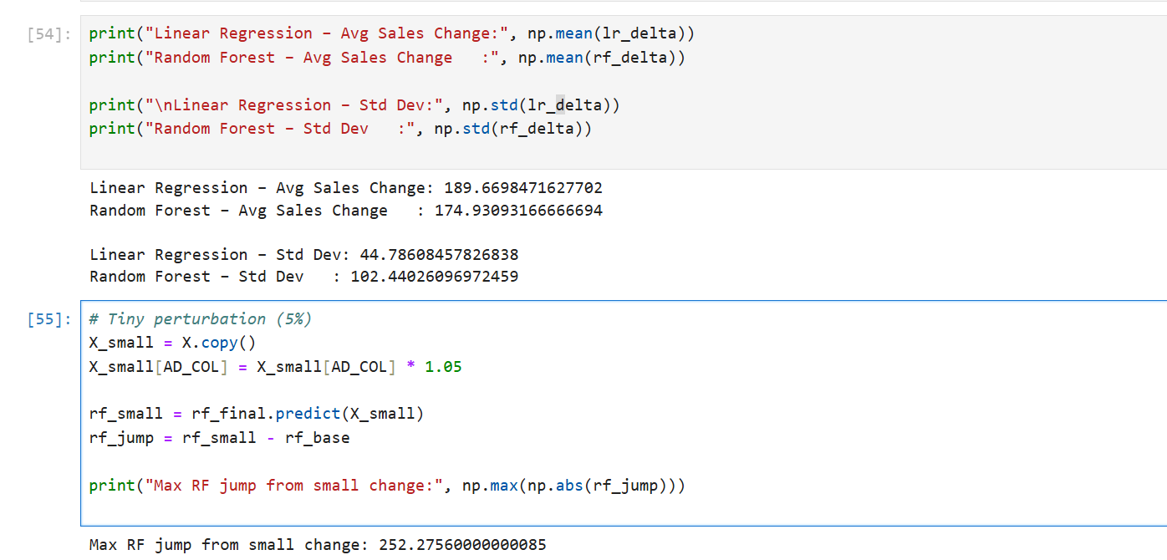
- Stakeholder trust is preserved
Final Understanding, Review, and Improvement Recommendations
Overall Understanding of the Deployed Model
The deployed Multiple Linear Regression model was selected and designed under strict constraints: non-technical review, budget-driven decisions, and infrequent (quarterly) updates. Within this context, the model performs its intended role safely and reliably, even if it does not maximize predictive accuracy.
The model demonstrates:
- Strong interpretability, allowing each prediction to be decomposed into understandable business drivers.
- Stable behavior over time, which is critical when decisions affect budgets and policies.
- Governance readiness, as the model can be explained, audited, and defended in regulated or high-accountability environments.
Rather than optimizing for technical sophistication, the model optimizes for decision trust.

Model Review Against Key Constraints
1. Non-Technical Stakeholder Review
- Coefficients provide direct, intuitive explanations.
- Predictions can be justified using simple cause–effect logic.
- No reliance on opaque transformations or black-box mechanisms.
Assessment: Fully satisfies interpretability requirements.
2. Budget Allocation Decisions
- Counterfactual analysis is reliable and monotonic.
- Marginal impacts are stable and economically plausible.
- Error is measured using MAE, which directly reflects financial risk.
Assessment: Suitable for high-stakes financial decisions.
3. Quarterly Model Updates
- Low sensitivity to small data perturbations.
- Coefficients remain directionally consistent across time.
- Reduced risk of sudden recommendation changes.
Assessment: Appropriate for infrequent retraining cycles.
Key Trade-Off Acknowledged
The model deliberately sacrifices maximum accuracy to gain:
- Stability
- Transparency
- Regulatory defensibility
This trade-off is intentional and appropriate given the business context. A more complex model would increase model risk without proportionate business benefit.
What Can Be Improved Without Violating Constraints
The following improvements strengthen the model while respecting all original constraints.
1. Mild Regularization for Coefficient Stability
Improvement:
Introduce very light Ridge regularization if multicollinearity increases over time.
Benefit:
- Reduces coefficient volatility
- Preserves interpretability
- Improves robustness without feature elimination
Why it respects constraints: Still parametric, transparent, and stakeholder-friendly.
2. Feature Governance Instead of Feature Explosion
Improvement:
Replace raw correlated features with business-approved composite indicators
(e.g., “Total Marketing Effort” instead of multiple ad channels).
Benefit:
- Reduces multicollinearity
- Improves clarity
- Aligns model inputs with how the business thinks
Why it respects constraints: Improves understanding rather than complexity.
3. Add Guardrails Instead of Model Complexity
Improvement:
Define deployment guardrails, such as:
- Maximum allowable prediction change quarter-to-quarter
- MAE thresholds triggering review
- Flags for structural breaks
Benefit:
- Prevents silent model failure
- Improves governance and trust
Why it respects constraints:
Improves safety, not sophistication.

4. Dual-Model Strategy (Advisory Only)
Improvement:
Use a non-parametric model in parallel for internal monitoring (not deployment).
Benefit:
- Detects changing patterns
- Signals when the parametric model may become outdated
Why it respects constraints:
Only the interpretable model drives decisions.
5. Enhanced Communication, Not Complexity
Improvement:
Standardize outputs into:
- Driver contribution charts
- Scenario tables
- Plain-language summaries
Benefit:
- Improves stakeholder confidence
- Reduces misuse of predictions
Why it respects constraints:
Strengthens adoption without altering the model.

When the Model Should Be Revisited
Despite good performance, the model should be paused or re-evaluated if:
- There is a structural break (regulation, competitor entry, pricing regime change)
- Business definitions or KPIs change
- Prediction errors exceed defined financial risk thresholds
In such cases, accuracy metrics alone are insufficient justification for continued deployment.
Final Review Verdict
- The deployed Multiple Linear Regression model is fit for purpose, defensible, and appropriate under the given constraints.
- Its strength lies not in technical complexity, but in its ability to support stable, transparent, and accountable decision-making.
- Future improvements should focus on governance, robustness, and communication rather than increased model flexibility.

